Edusites Guide to using online resources –
Terms and conditions state that Edusites resources in any form can only be used in the subscribing school.

This takes a few minutes to accomplish and you have a student/classroom ready resource.
Log in to the Edusite you want to edit from.

Tip
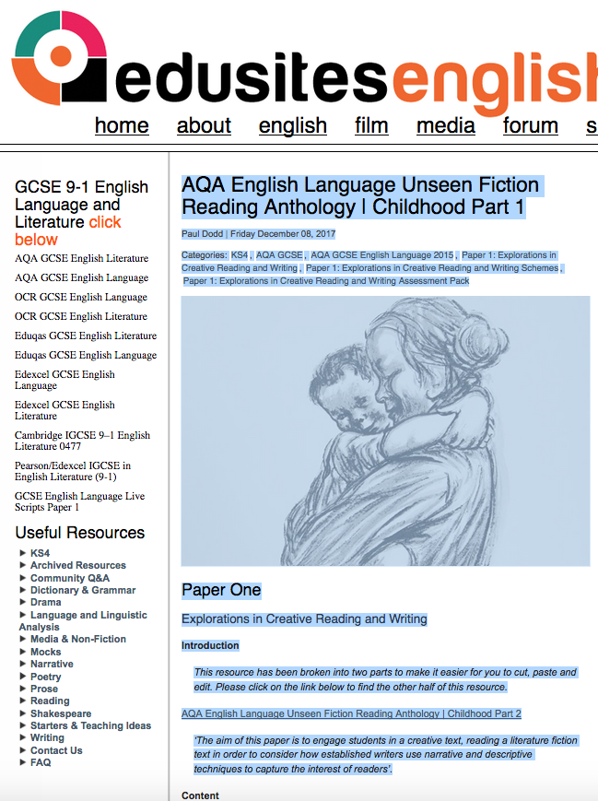
If you are working on a small screen like a laptop you can change the zoom facility to get more of the text on the screen.

Move the curser to the top of the resource and select the central column of text and images.

Tip
Don’t use select all as it may copy the two sidebars giving you a long editing job later.

Cut and paste the text onto a word document

Tip
At the stage you can add or delete any text. For example you might make suggestions about what students might do with the texts. You might give students the opportunity to make new questions, add some helpful tips for students who may need more direction, differentiate the resource into sections you think may be more or less challenging.
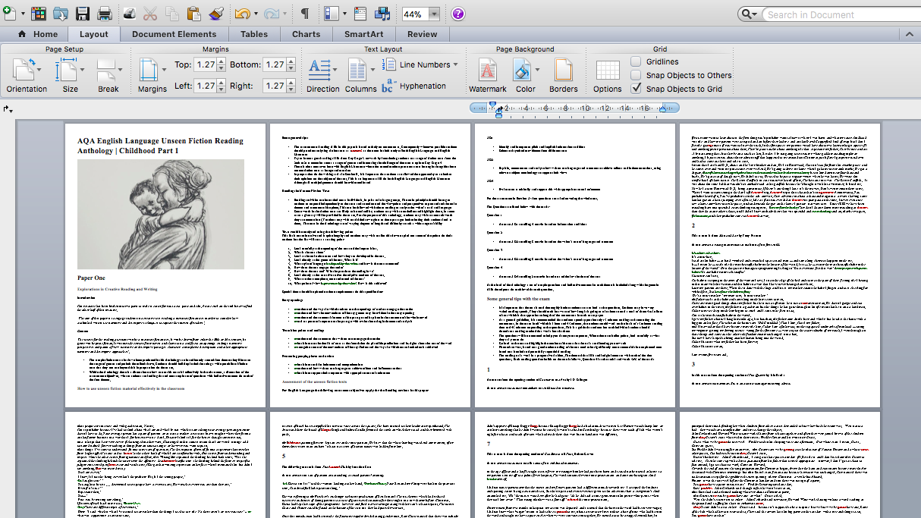

- Change the margins to narrow.
- Take out any hyperlinks.
- Check the font size
- Insert page numbers

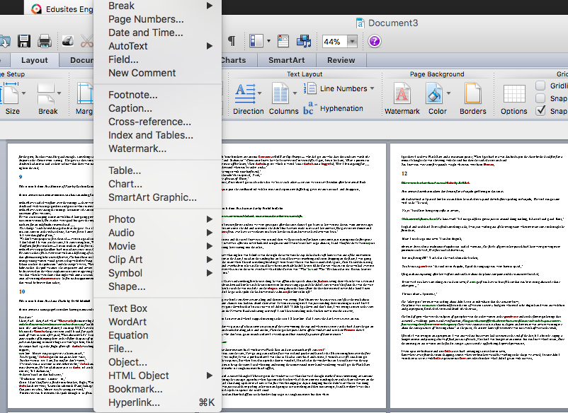
Print using the two pages to a page and booklet settings. You might need advice about this from your reprographics department.

Or send the A4 document to your reprographics department to print as an A5 booklet.

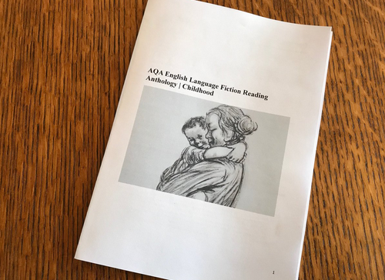
Like Blue Peter you now have one classroom ready resource

On Edusites there are more than 20 chapters containing in excess of 100 texts to use as unseen practice.

Stuck? Call 01604 847689
Or
07702897427

